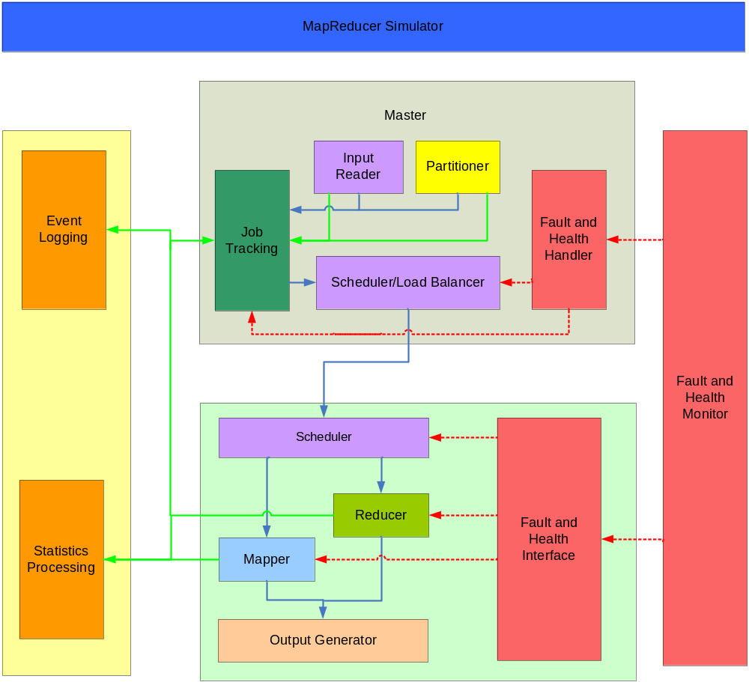

The Green lines are more for information passing such as “I’m done”

The red lines for fault/health monitoring and handling

The blue lines are the data flows

